Marine Safety Information Bulletin
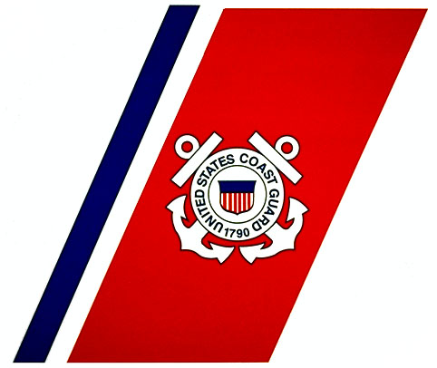

Commandant MSIB Number: XXX-010
U.S. Coast Guard Date: August 15, 2012
Directorate of Marine Safety, Security & Stewardship Contact: LT Matthew Layman
2100 Second Street, SW, Stop 7355 Phone: (202) 372-1160
Washington, DC 20593 E-Mail: Matthew.d.layman@uscg.mil

Extended Expiration Date Transportation Worker Identification Credential (TWIC)

Starting August 30, 2012, if you hold a TWIC that expires on or before December 31, 2014 and you are a U.S. citizen or U.S. national you will be able to replace your expiring TWIC with a 3-year Extended Expiration Date (EED) TWIC. The EED TWIC is a one-time temporary extension option intended to provide convenience and cost-savings to workers. The EED TWIC has a reduced cost of $60 and requires only one visit to an enrollment center. This guidance provides direction to the maritime industry on the eligibility and application process for an EED TWIC.

Eligibility:
- Individuals are eligible to obtain a 3-year EED TWIC if they meet the following requirements:
- They are a U.S. Citizen or U.S. National AND
- Their current TWIC is valid and not revoked AND
- Their current TWIC expires on or before December 31, 2014.
- As long as an individual maintains eligibility, he/she can obtain a 3-year EED TWIC prior to the expiration of their current TWIC before December 31, 2014.
- TWIC holders who are not U.S. citizens or U.S. nationals are required to enroll for a standard 5-year replacement upon expiration of their current TWIC.

Application Process:
- Call the TSA TWIC Help Desk (1-866-347-8942, Mon–Fri, 8AM to 10PM Eastern) to begin the application process and to confirm eligibility.
- Once the EED TWIC arrives at the enrollment center specified by the individual, the individual will be notified for pick up and activation of their 3-year EED TWIC.
- The original TWIC shall be turned in at the enrollment center at the time of activation of the EED TWIC.
- The new EED TWIC will have an expiration date three years from the original expiration date, regardless of when application for the EED is made.

More information on the EED TWIC, location of enrollment center, and related materials may be found at www.tsa.gov/twic.

If you have any questions or concerns regarding this bulletin, please contact Lieutenant Matthew Layman, Commandant (CG-FAC-2) U.S. Coast Guard, at (202) 372-1133.

-uscg-

